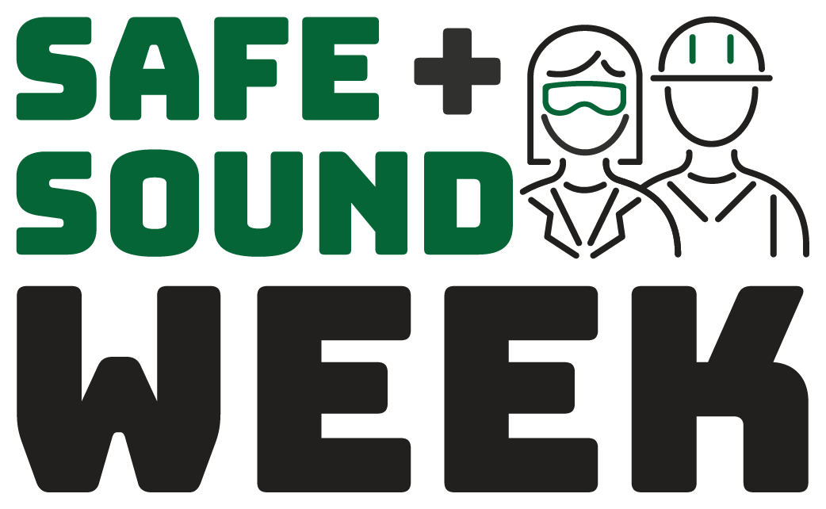 | We are Safe + Sound at Work. Join Us.  Sign up at osha.gov/SafeAndSoundWeek  August 11-17
Participating Businesses:

