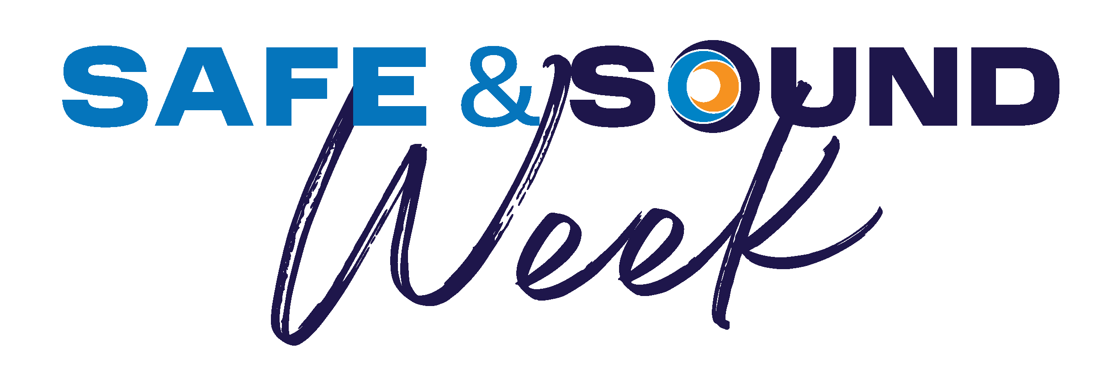 | We are Safe & Sound at Work. Join Us.  Sign up at osha.gov/SafeAndSoundWeek  August 10-16

