Options for Using MS Forms for the Annual Evaluation

Instructions for Annual Evaluation Link

Receiving the OSHA Annual Evaluation Link
You will receive a link from OSHA to the MS Forms Annual Evaluation.
Depending on how your Department or Agency wants to manage the evaluations and the responses collected, will guide which option that is used for the MS Forms Annual Evaluation.

Options for Managing the Link
- Send out the OSHA link received: All of your data will drop into OSHA’s MS Forms results.
- Duplicate the evaluation so that you can collect, manage, and share your results. (using this option will allow you to keep your results confidential until you are ready to share)

Duplicating the Evaluation
If you want to manage and own your agency or department’s data, you will need to duplicate the original evaluation to be your own.
Duplication:
- Click the OSHA link (from the email or memo), the evaluation will show on the screen. A duplicate button will be on the top right corner. Activate that button to duplicate.
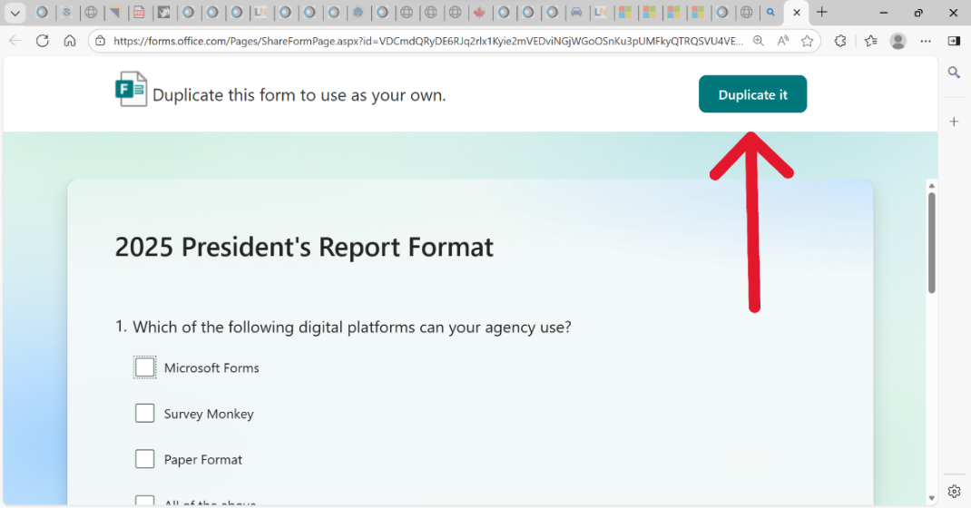
- Once duplicated, it will have the word ‘copy’ in the title. Click on the title to rename it as you wish.
  - Caution: The form is now completely editable, so the questions can also be changed or deleted by the new owner (aka: you).
- After duplicating the OSHA link go to your MS Forms.
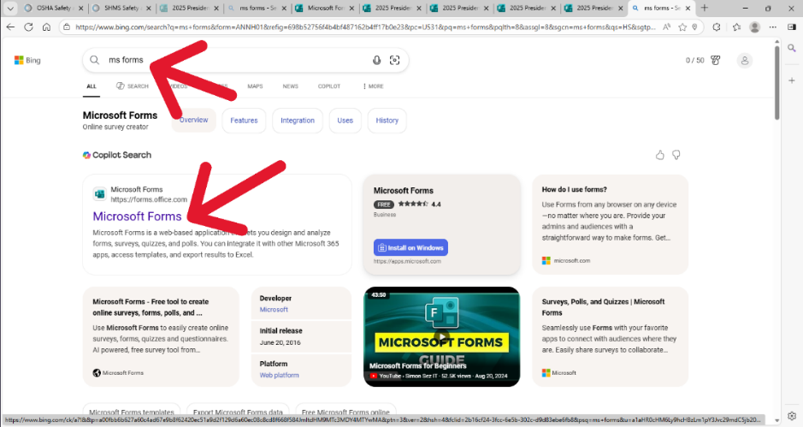
  - The newly created form will be in to your MS Forms dashboard.

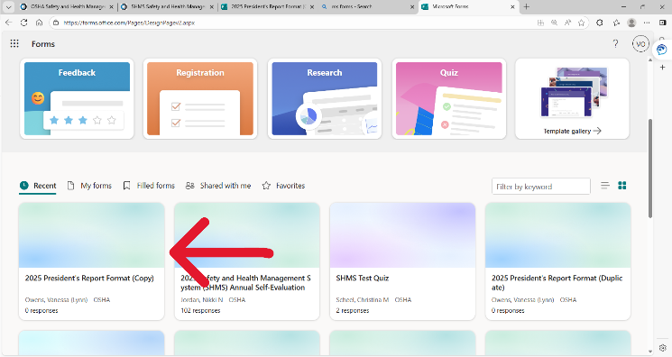

    - This will be the version that you send to your team.
Creating a link to send out:
- Open the newly created evaluation located on your MS Forms dashboard. 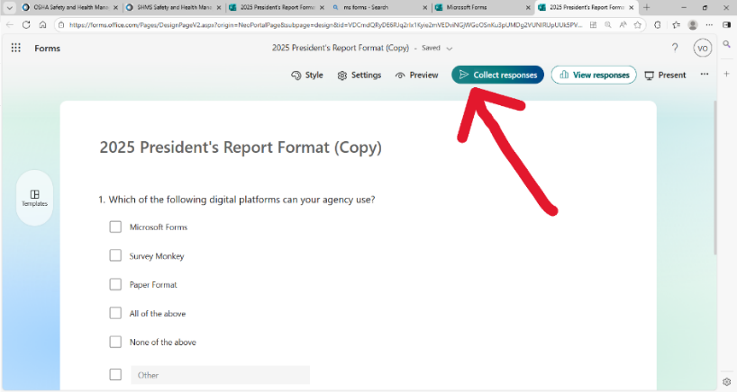

- Click on collect responses.

  - A sub window opens titled ‘Send and collect responses’
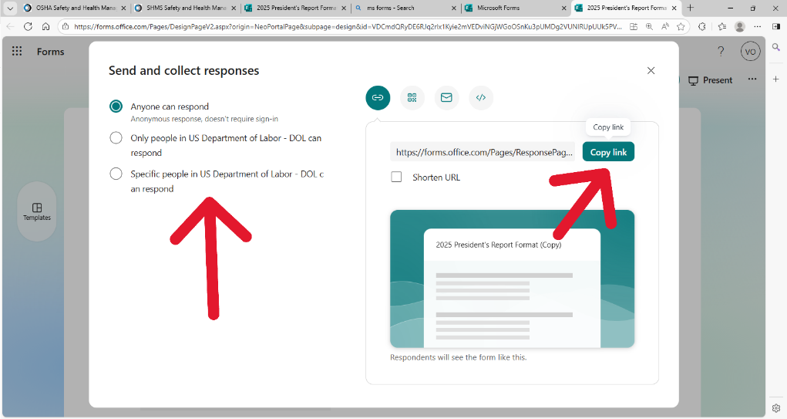
  - Choose who in your agency has permission to respond.

- Click copy link; it is now ready to paste into an email, chat, or any other communication method you choose. You will now start collecting responses to your MS Forms profile.

Collecting responses:

- From your MS forms dashboard, open the Annual Evaluation, click ‘view responses’ on the top right corner (only the owners can see this information).
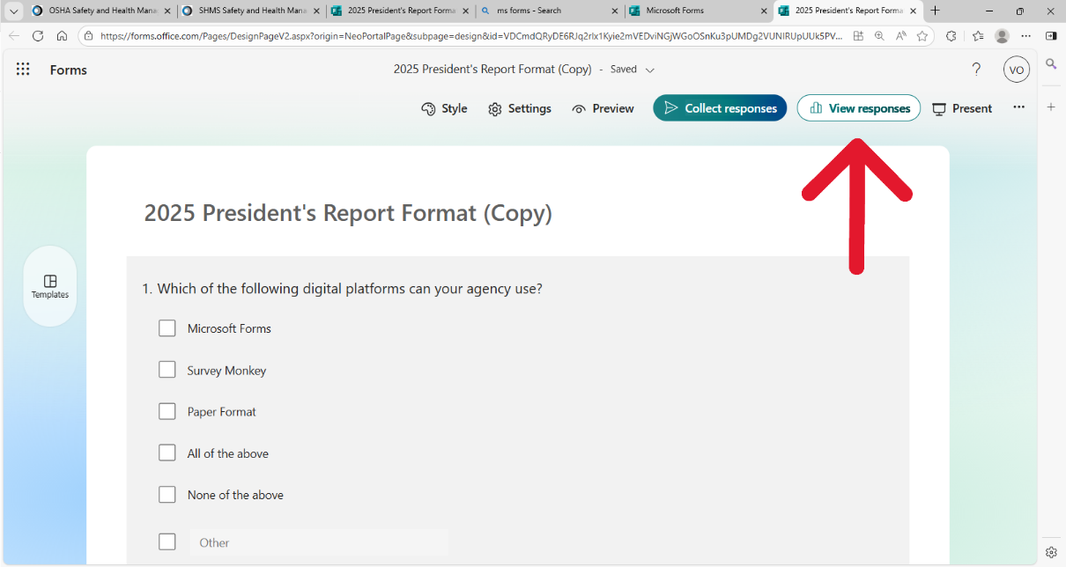
  - This window will show the response overview and ‘Insight and actions’ option.
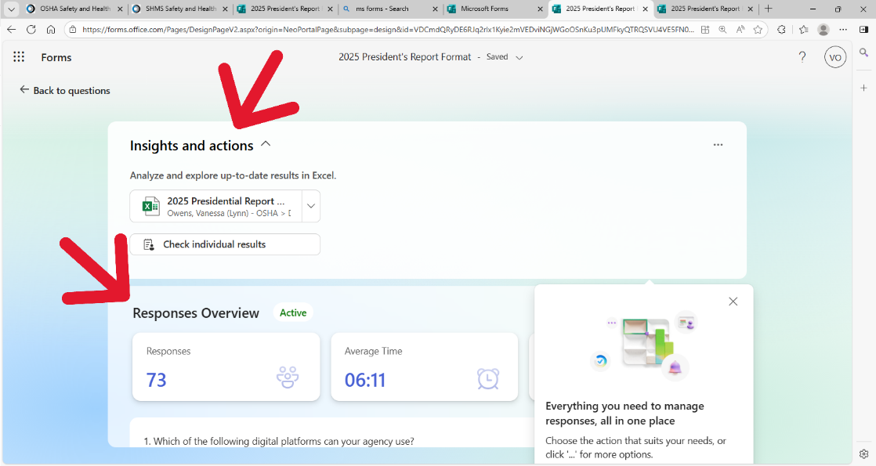
    - The ‘Insight and actions’ option is available so owners can download copies or open in excel desktop.
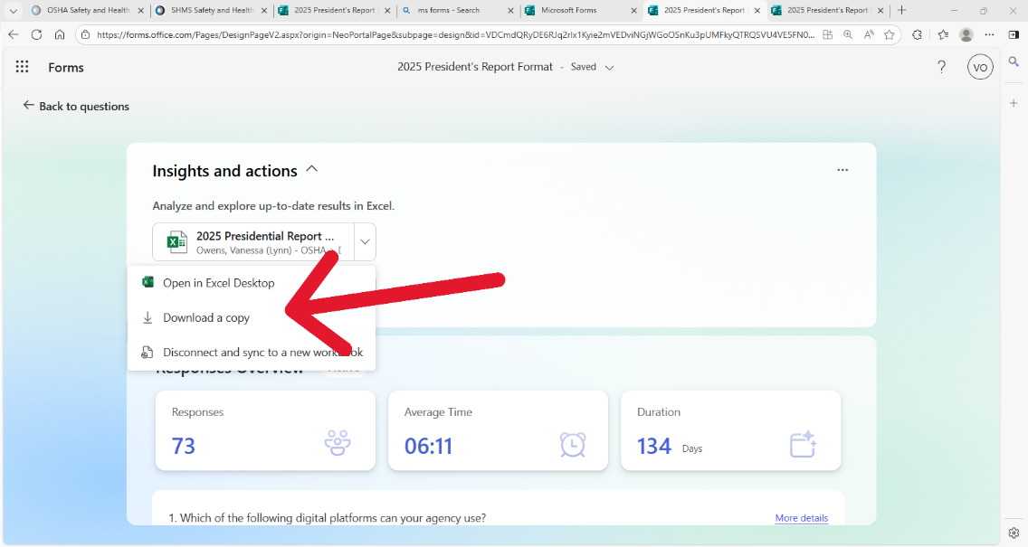
    - From the same screen under the three dots in the upper right-hand corner, allows the user to delete all responses, print a summary, and/or share the results.
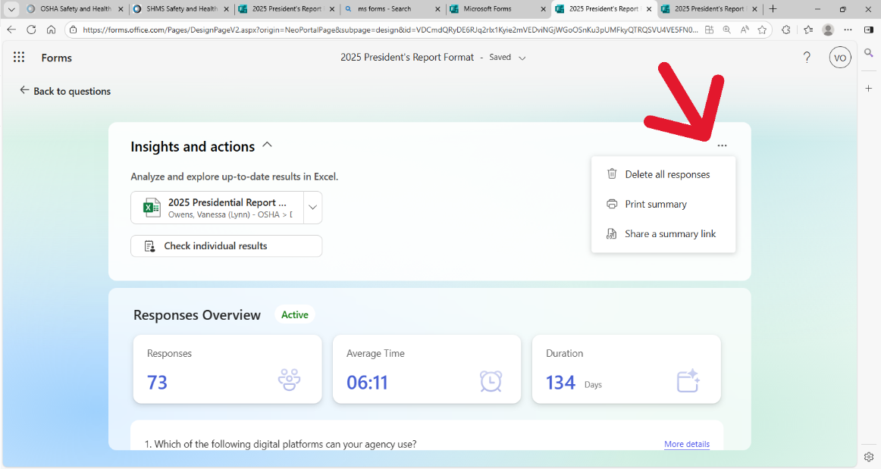
NOTE: End-users that want a copy of their responses may print the results by clicking the three bullets at the top right corner from their evaluation.
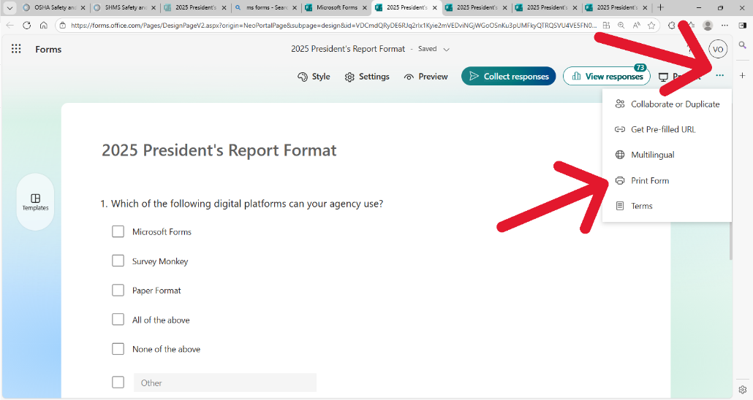

Compiling results: For those of you collecting multiple surveys, you will need to combine the Excel results from each survey into one main version for submitting back to OSHA.

