OSHA’s 2026 Trench Safety Key Messages
Reducing the number of fatalities in trenching and excavation work is a shared responsibility that goes beyond a single worksite or company, and we urge you to join us in this critical mission. Spread awareness by sharing safety information, implement robust safety protocols within your own organizations, and foster a culture where every employee feels empowered to speak up about safety concerns.
Here are some key messages, articles, and graphics you can share to help spread the word about trench and excavation hazards.

Short
Every year, workers lose their lives in trench collapses that could have been prevented.
Protect yourself and your team:
✅ Never enter an unprotected trench
✅ Use protective systems like shoring or trench boxes
✅ Inspect trenches daily
Learn more: osha.gov/trenching-excavation

FACTS:
➡ A trench collapse can happen in seconds
➡ 1 cubic yard of soil weighs as much as a car
➡ Most trench fatalities occur in trenches less than 10 feet deep
Don’t take chances. Follow OSHA’s trenching standards: osha.gov/trenching-excavation/construction

Before you dig:
✔ Plan the job
✔ Protect the trench
✔ Train your crew
Access free resources and guidance from OSHA: osha.gov/trenching-excavation/resources

⚠️ Spread the word on trench safety! ⚠️
For incident-free excavation work, plan ahead, use proper trench protections, and inspect trenches daily. More tips: osha.gov/trenching-excavation

[ORGANIZATION NAME] is committed to reducing trenching and excavation fatalities — because every worker should come home safe.
Learn more and share lifesaving resources: osha.gov/trenching-excavation

Long
Deadly trench collapses can happen quietly and without warning. They’re also preventable. Protect your crew by ensuring critical safety measures are in place: always use a protective system, inspect trenches daily before work begins, and keep excavated soil at least 2 feet from the edge. Don't take chances with your team’s safety.
🔗 Learn more at osha.gov/trenching-excavation.

Never underestimate the physics of a trench:
➡ A cave-in is over in seconds
➡ Just 1 cubic yard of soil can weigh as much as a car
➡ Most fatalities happen in trenches less than 10 feet deep
Saving a life is worth the time it takes to do it right. Follow OSHA’s required trenching standards and find resources to plan the job safely: osha.gov/trenching-excavation/construction

Great trench safety begins before you break ground. A proactive approach is the best way to prevent a tragedy. Remember these three key steps:
1) Plan the job by evaluating the soil and marking utilities.
2) Protect the trench with a proper system before anyone enters.
3) Train your crew to recognize the hazards.
OSHA provides free resources to help you build a culture of safety. Access them at osha.gov/trenching-excavation/resources.

Preventing trenching fatalities is a responsibility we all share. [ORGANIZATION NAME] is committed to ensuring every worker returns home safely at the end of the day. Join us in this critical mission by sharing safety information and fostering a culture of safety on every job site.
🔗 Learn more and find resources to share: osha.gov/trenching-excavation

Drop-in Articles

Trench Safety: 3 Essential Steps
Effective trench safety doesn't start when the excavator does — it starts with a plan. A proactive approach built on three pillars can eliminate the risks and ensure every project is completed safely.
1. Plan the Job: Before breaking ground, a thorough plan is essential. This includes locating and marking all underground utilities, evaluating the soil type to understand its stability, and designing the appropriate protective systems for the conditions.
2. Protect the Trench: No worker should ever set foot in a trench until a protective system is fully in place. Whether it's by sloping the soil to a safe angle, installing shoring to support the walls, or using a trench shield to protect workers, this step is non-negotiable.
3. Train Your Crew: A safe site is an educated site. Every crew member must be trained to recognize trenching hazards, understand the procedures to mitigate them, and know the emergency response plan. An empowered team is the first line of defense against accidents.
OSHA can help build a culture of safety from the ground up, offering free resources to support planning and training efforts. Find standards, safety checklists, educational materials, and more: osha.gov/trenching-excavation/resources

A Moment of Prevention Can Save a Life
Deadly trench collapses can happen quietly and without warning, but they are preventable. Never underestimate the physics of a trench. A cave-in is over in seconds, and just 1 cubic yard of soil can weigh as much as a car. While many assume the risk is only in deep excavations, most fatalities occur in trenches less than 10 feet deep.

Protect your crew by ensuring critical safety measures are in place. Always use a protective system, inspect trenches daily before work begins, and keep excavated soil at least 2 feet from the edge. Don't take chances with your team’s safety — saving a life is worth the time it takes to do it right.

Preventing trenching fatalities is a responsibility we all share. [ORGANIZATION NAME] is committed to ensuring every worker returns home safely at the end of the day. Join us in this critical mission by sharing safety information and fostering a culture of safety on every job site.

To learn more about OSHA’s required trenching standards and find resources to plan your jobs safely, visit osha.gov/trenching-excavation.

Graphics
Square 1080x1080 | Vertical 1080x1350
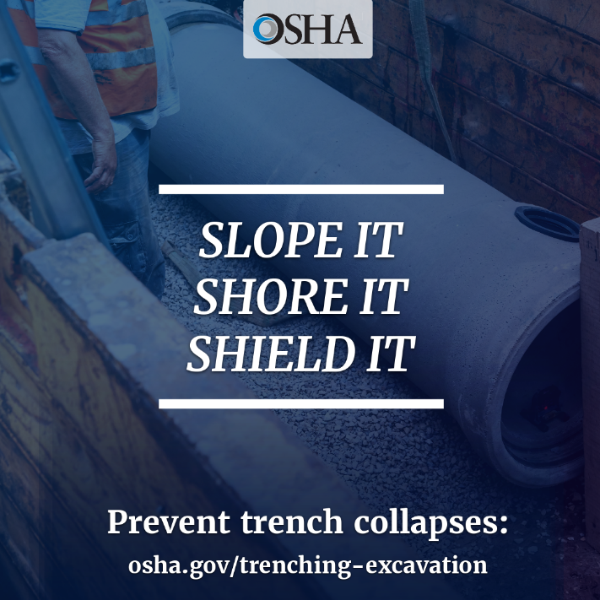  Download | 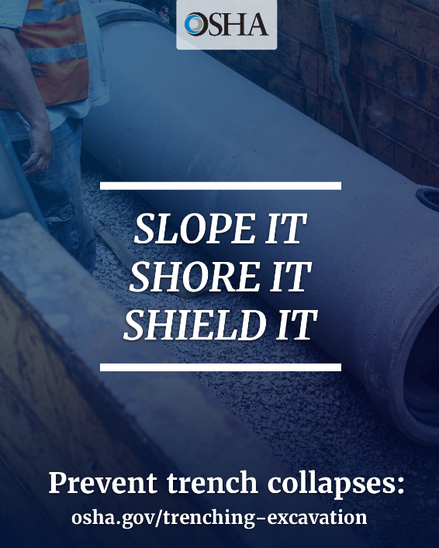  Download
  Download |   Download
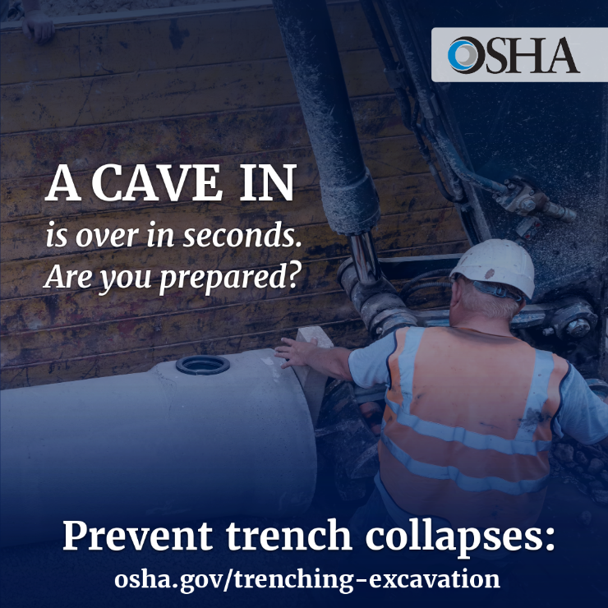  Download | 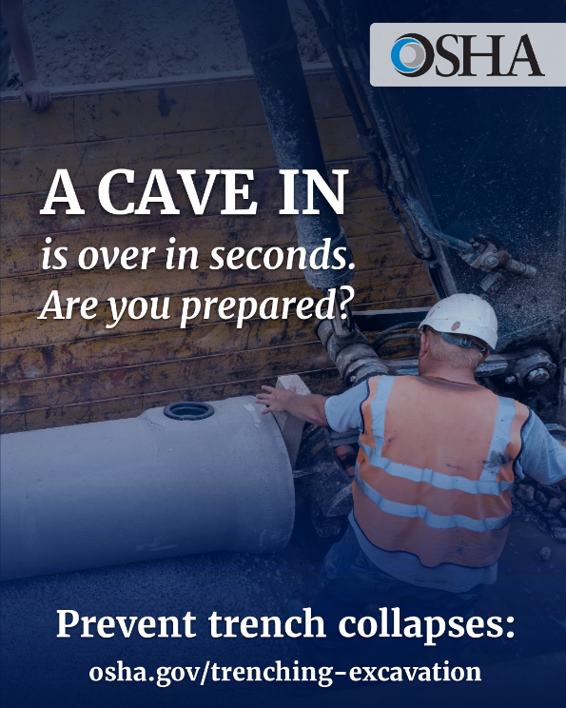  Download
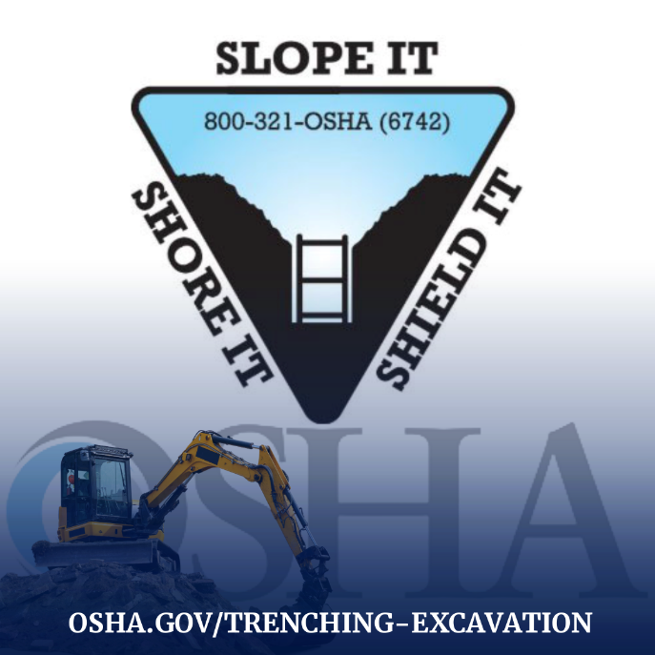  Download | 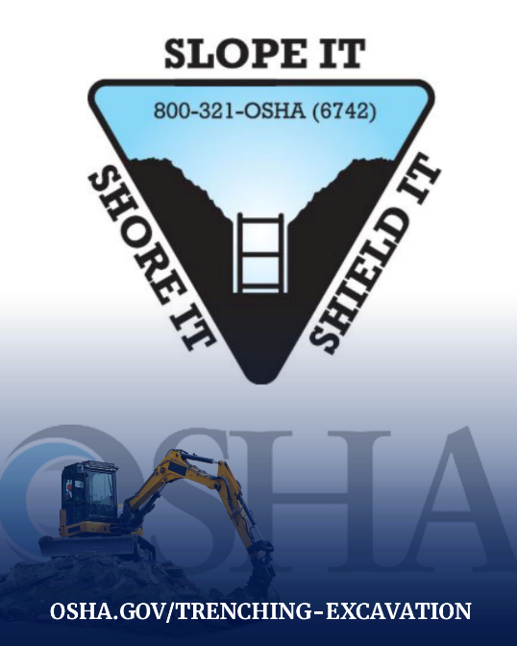  Download

